Azure Data Engineer: Batch 6

(October 2023)

**Submitted by: Roopmathi Gunna**

# **Assignment 7**: ADF Pipeline 4

Easy Questions:

1. Create a pipeline named 'GetMetaData_Example' to fetch the list of all the files available inside the ADLS folder.

Here I have created GetMetaData Activity in my pipeline to fetch the names of the files.

Here is a snapshot of my pipeline with output:

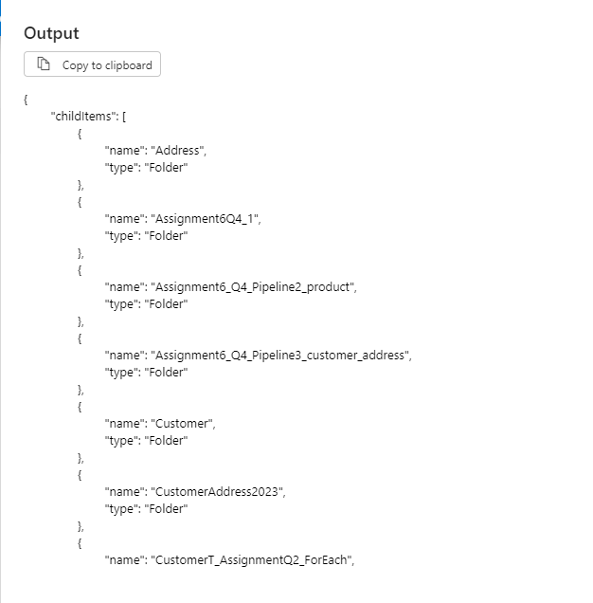

2. Create a pipeline name 'Foreach_Example' to copy the Customer and Customer address table data into ADLS using the one copy activity.

Output:

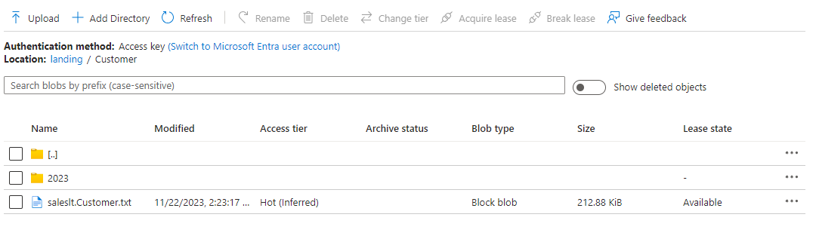

Tough Questions:

3. Create a pipeline that first checks whether the Customer.csv file is available in the folder location. If it exists copy the file data to the Customer Table in SQL DB

Here is the pipeline I created which includes a GET Meta Data Activity and an IF Conditional activity:

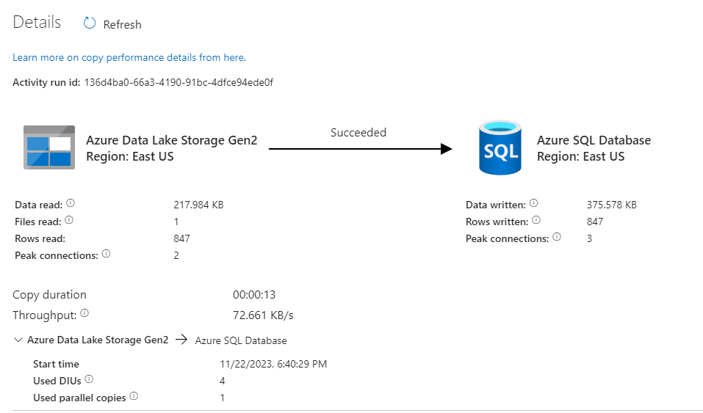

4. Create a pipeline that will create the incremental pipeline using the table instead of HighWaterMark File.

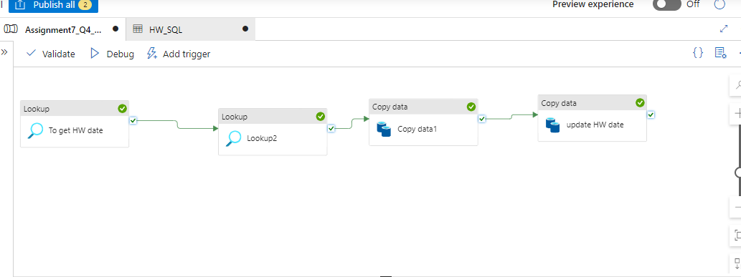

5. Create a pipeline name 'Foreach_Example2' to copy the below information using just one copy activity.

- All the product table data where productid > 100

- All the customer table data where Customer id>100 and Customer id <1000



